

Travlr Getaways

CS 465 Project Software Design Document
Version 3.0

Table of Contents

CS 465 Project Software Design Document 1
Table of Contents 2
Document Revision History 2
Executive Summary 3
Design Constraints 3
System Architecture View 4
Component Diagram 4
Sequence Diagram 6
Class Diagram 7
API Endpoints 8
The User Interface 9

Document Revision History

Version | Date | Author | Comments
1.0 | 03/22/2026 | Bradley Gualco | Added MVC Routing and Changed Static HTML to Templates with JSON
2.0 | 04/05/2026 | Bradley Gualco | Added Sequence Diagram, Class Diagram and updated API Endpoints
3.0 | 04/19/2026 | Bradley Gualco | Added additional API Endpoints, Added screenshots of User Interface, Added Summary of Angular and Express project structure, Added Description of the SPA and API Testing

Executive Summary

The appropriate architecture for the Travlr web application is the MEAN stack for development. The MEAN stack will allow for the transition from a static HTML website to a dynamic website that will create a user-friendly interface for customers and administrators. This will include the MongoDB NoSQL database to hold information relevant to the website (Devlin, 2025). This type of database uses documents in BSON for great scalability and performance with queries. In addition, Express will be used as the framework for RESTful APIs and routing (Devlin, 2025). Angular is another framework that will be used to create a single-page application (SPA). Angular is the front-end tool for building the interface for the user with the browser. It provides routing (to move between pages in the SPA), data binding (keeping the data refreshed) and components (buttons, menus, and so on) (Devlin, 2025). Lastly, Node.js will be used to run JavaScript to handle things like events (button-pushing) and handling multiple requests. The MEAN stack helps speed up response times for customer experience and the use of JavaScript helps consistency across various platforms. For administrators, it helps speed up the addition of new features and aids with faster fixes with centralized monitoring.

Design Constraints

In the MEAN stack, there are some concerns to consider. MongoDB, for example, can have limitations on its document size and queries can be slow for large databases (Wahab, 2025). Slow websites can be frustrating for some users, and they may navigate to alternatives if it is a substantial problem. Some security considerations when using the MEAN stack are preventing injection attacks (Ram, 2024). Whitelisting, role-based access, encryption, logging and other techniques should be combined to prevent such attacks on the MongoDB database (Ram, 2024). Injection attacks use unvalidated input to hijack the server or provide unwanted instructions that can leak private data (Cyber Writes Team, 2026). When using the MEAN stack, there are outside dependencies and some libraries in such a stack may be deprecated and may need periodic updating.

System Architecture View

Component Diagram

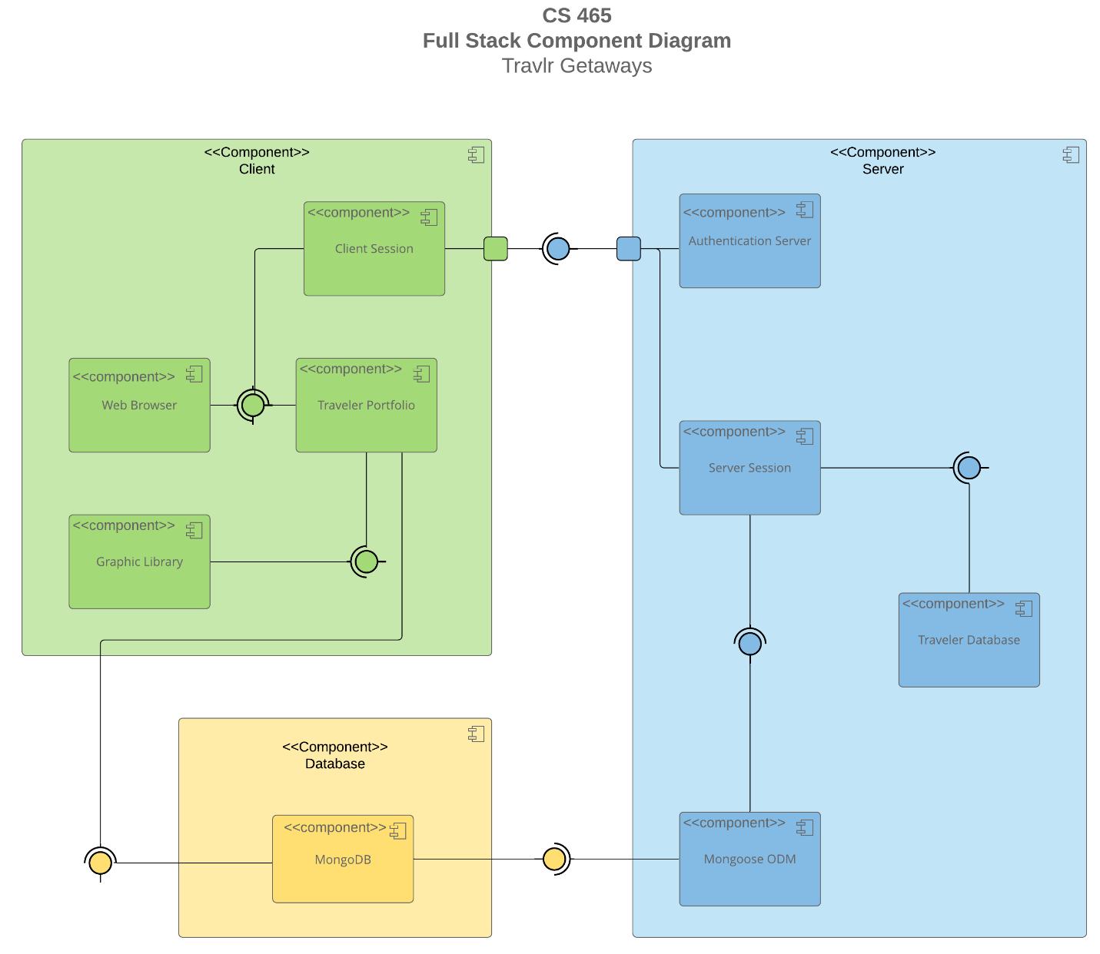

A text version of the component diagram is available: CS 465 Full Stack Component Diagram Text Version.

In the diagram, the green block represents the client portion of the website. This has client sessions, web browser, traveler portfolio, and graphic library. This is the front-end portion of the website. The client session holds the information for a particular user (personalization), and their portfolio specifics are displayed in their web browser. This green block is Angular doing its job for a positive user experience. This is the “View” in MVC architecture.

In the blue block, there is a representation of the server-side portion of the website. The client will type in their authentication information, and the authentication server will validate the information entered. Once validated, the server session will start. This will reach out to the traveler database that holds specifics about travel. Mongoose ODM uses MongoDB with Node.js to perform validation and to build queries. This is the “Controller” in MVC architecture. This is part of the back-end.

The yellow block is the MongoDB database that holds the user data and allows for CRUD operations. This can help create documents, read documents, update documents and delete documents. The documents are stored as BSON in a NoSQL database. This is the “Model” in MVC architecture.

Express handles the HTTP requests and URL routing. Node.js and Mongoose work together to handle the CRUD operations (Yadav, 2024). Express defines the API routes for Node.js and Mongoose to do their job. Angular handles the templates by binding data to them.

Sequence Diagram

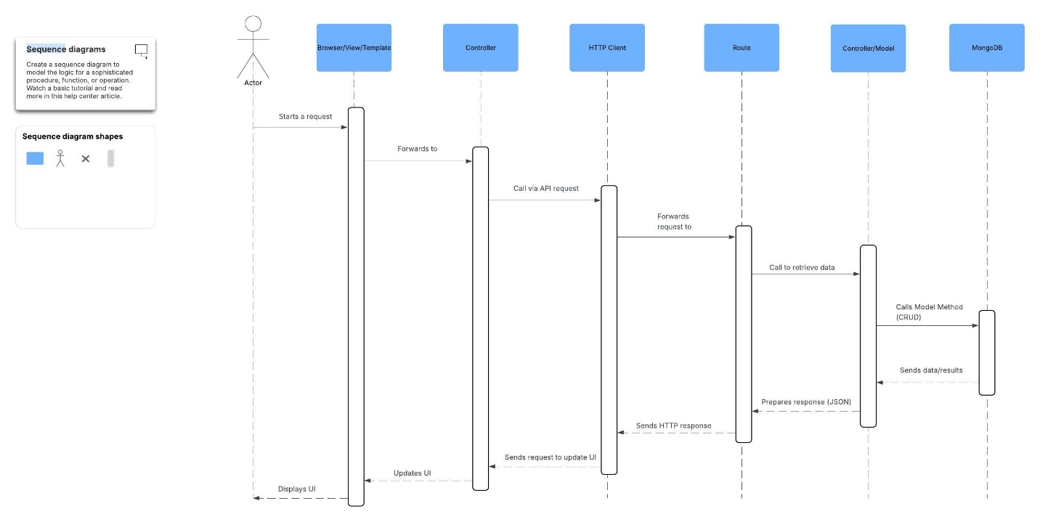
The Actor initiates a request on the Browser. The request is forwarded to the Controller. The Controller decides which API request to make and makes a call to the HTTP Client. The HTTP Client forwards the request to the Route which makes a call to retrieve the appropriate data requested to the Controller for the Model. The Controller makes the Create, Read, Update, or Delete request to MongoDB. MongoDB follows the request and returns feedback or sends back an error message. The feedback/message is sent back to the Controller. The Controller prepares the response using JSON and sends to the Route. The Route sends an HTTP response to the HTTP Client. The HTTP Client sends a request to the Controller to make updates to the User Interface. The Controller updates the User Interface and displays it to the Actor via the Browser.

Class Diagram

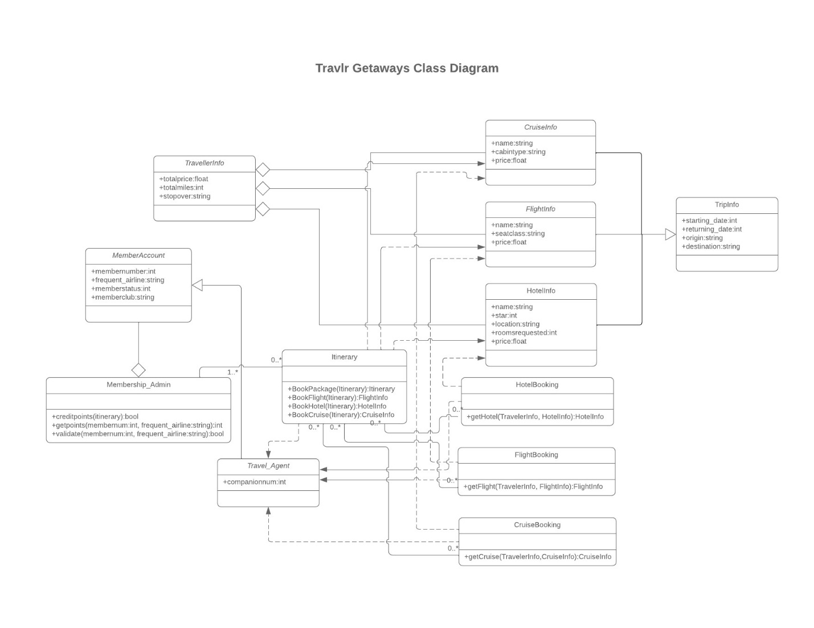
The Membership_Admin has a MemberAccount and is associated with Itinerary. A single Membership_Admin can be associated with 1 or more Itineraries. Each Itinerary can be associated with 0 to many Membership_Admins. There can be 0 to many Itineraries. The Itinerary includes CruiseInfo, FlightInfo, and HotelInfo. FlightInfo can include TripInfo. Each CruiseInfo, FlightInfo, and HotelInfo has TravellerInfo. The Itinerary is associated with HotelBooking, FlightBooking, and CruiseBooking. There can be 0 to many bookings. The MemberAccount has a Travel_Agent and the Travel_Agent uses the Itinerary, HotelBooking, FlightBooking, and CruiseBooking.

API Endpoints

Method | Purpose | URL | Notes
GET | Retrieve list of trips | </api/trips> | Returns all active trips
GET | Retrieve single trip | </api/trips/:tripCode | Returns single trip instance, identified by the tripCode passed on the request URL
POST | Add a new trip | </api/trips> | Allows a trip to be added with hints in the fields for Admin
POST | Register | </api/register> | Allows a user to register
POST | Login | </api/login> | Allow login and authentication for users
PUT | Update a trip | </api/trips/:tripCode | Allows a trip’s information to be updated in the database, identified by the tripCode passed on the request URL
DELETE | Delete a trip | </api/trips/:tripCode | Allows a trip’s information to be deleted in the database, identified by the tripCode passed on the request URL

The HTTP methods used on the same resource allows different and common tasks to be accomplished. GET is helpful for reading information in the database. POST is useful for adding information to the database. PUT allows one to make updates, edits, and changes to the database. DELETE will remove documents from the database. These methods allow the intentions of the user to be executed efficiently and fast, in an organized way. This creates a decoupling system that is flexible and scalable, and the components can be added or subtracted easily. The separation allows each option to be independent and keeps the rest of the interface stable.

The User Interface
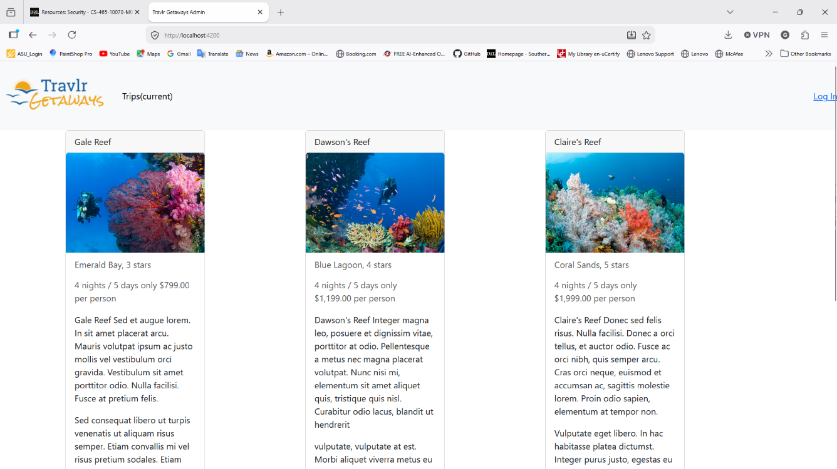

Figure 1 shows the Travlr Getaways Admin page with Login option.

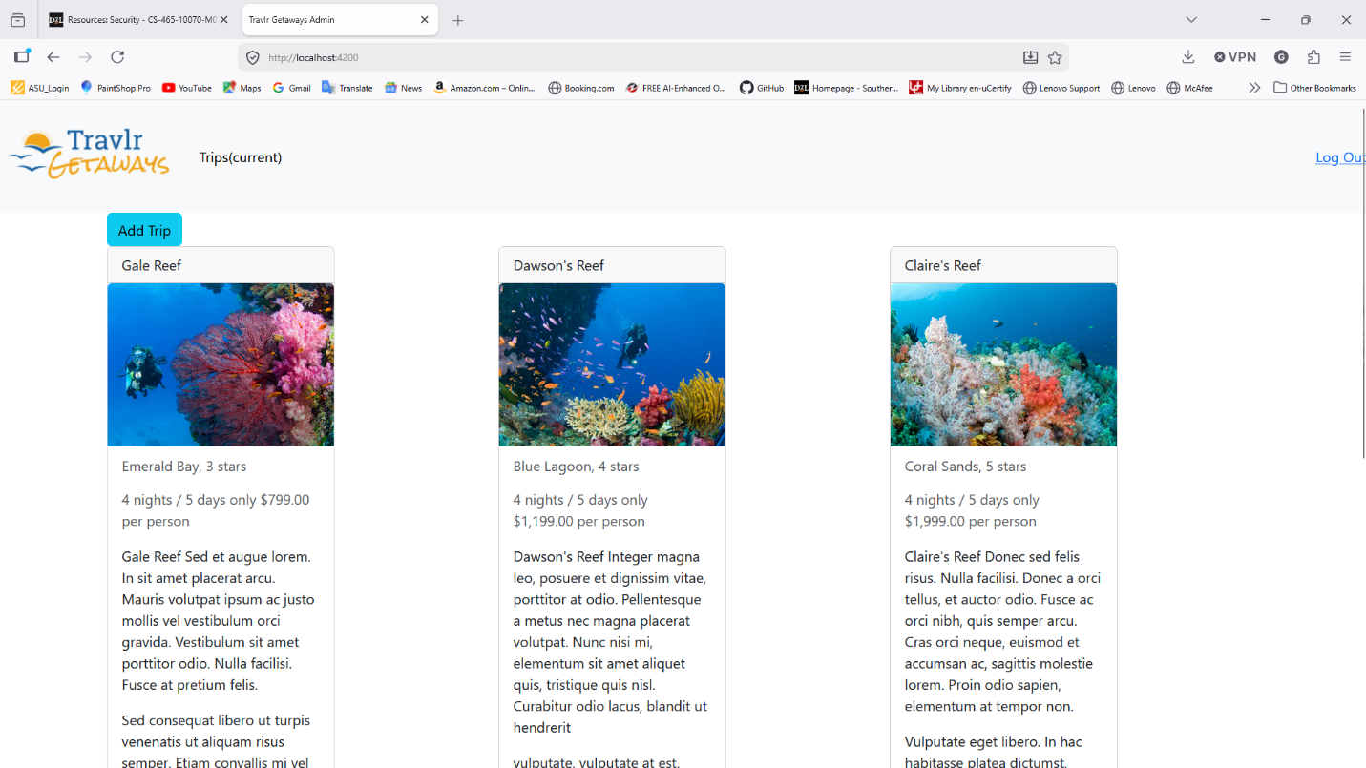
Figure 2 shows the screen where trips can be added after logging in.

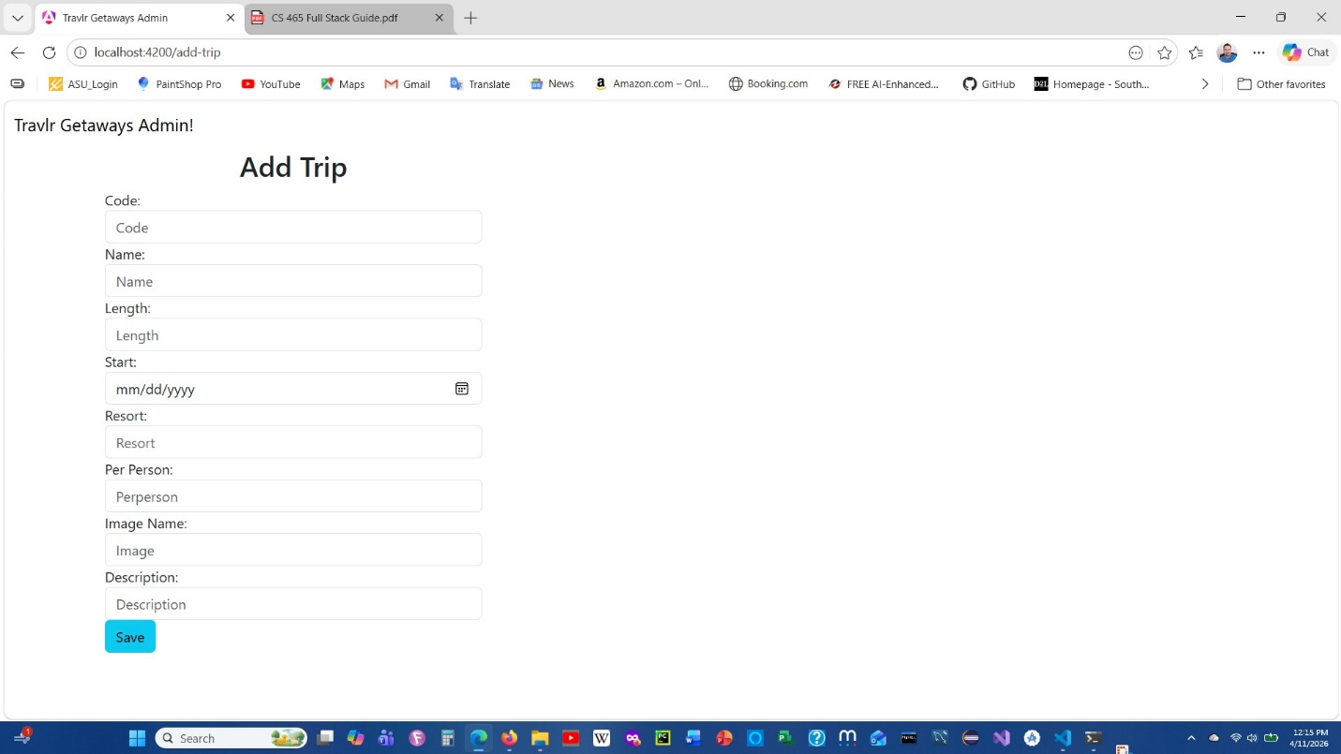
Figure 3 shows the screen where trips can be added to the database.

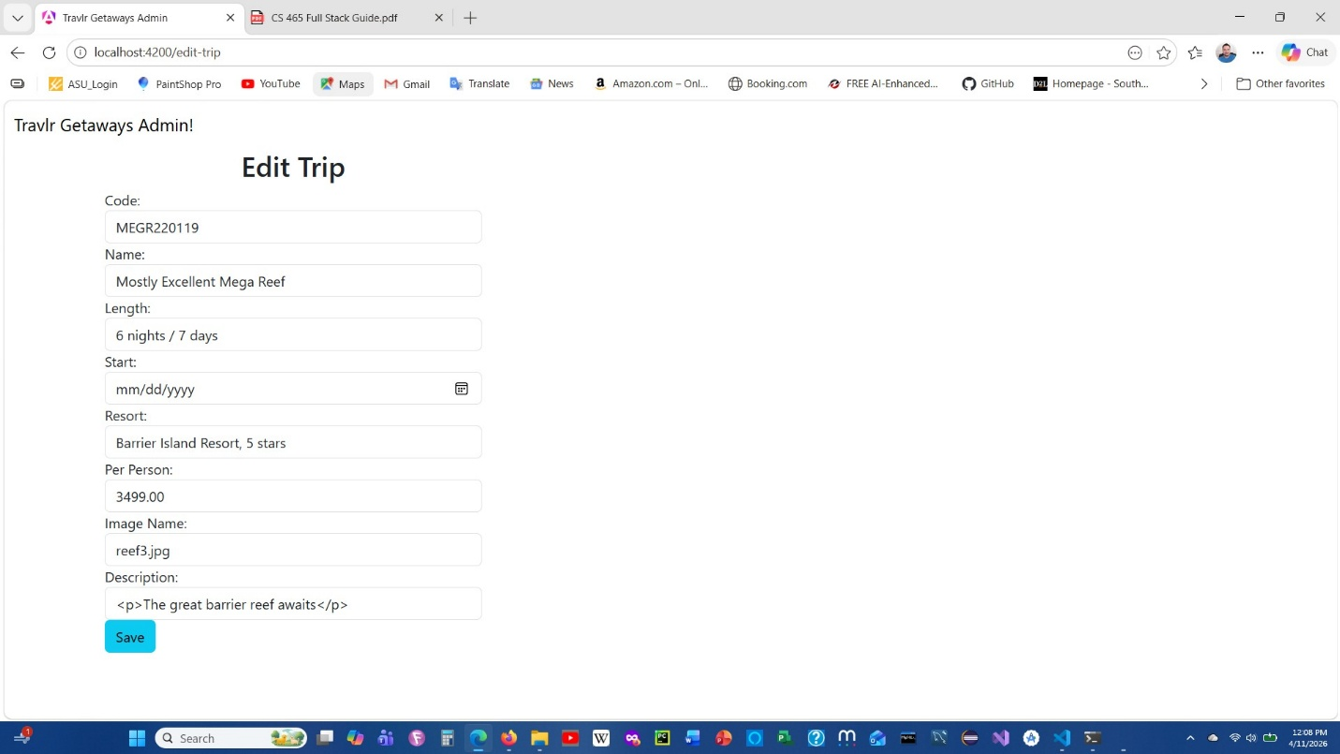
Figure 4 shows the screen where editing can be done to a trip and data is filled in automatically.

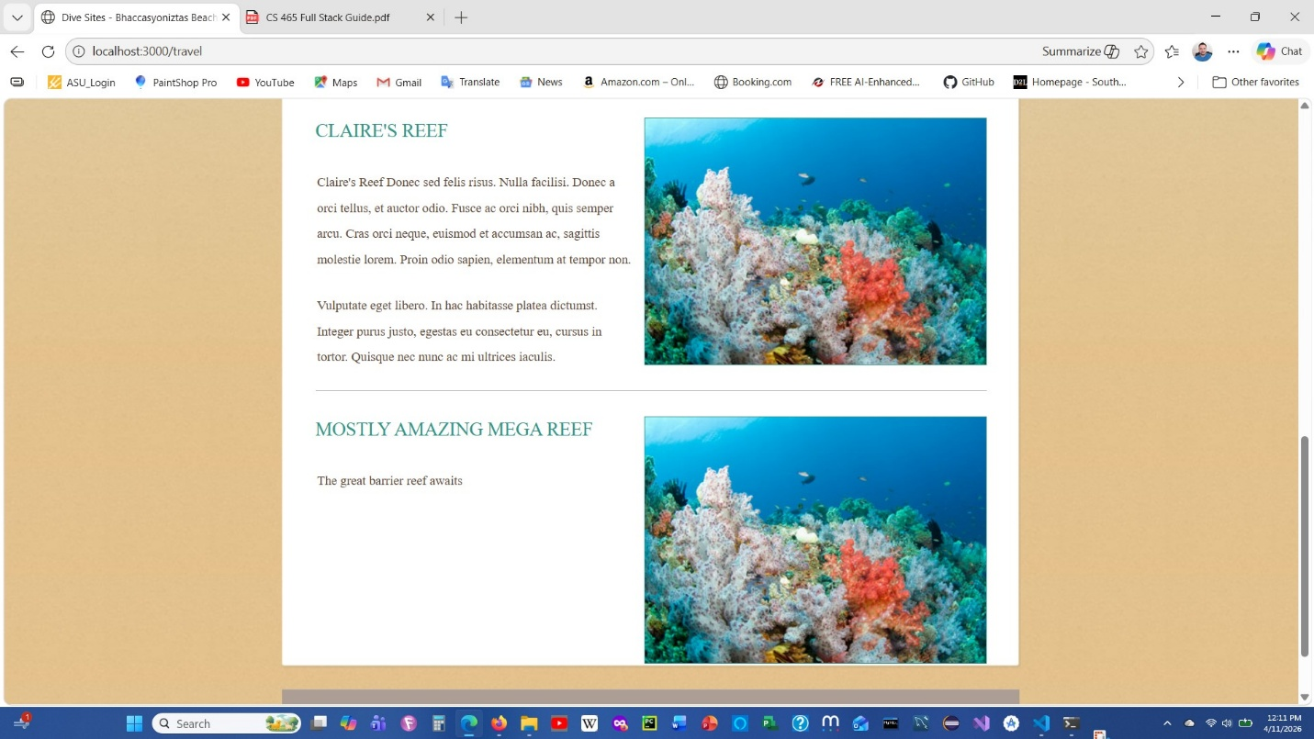
Figure 5 shows the customer website with the updated database information on the trip options.

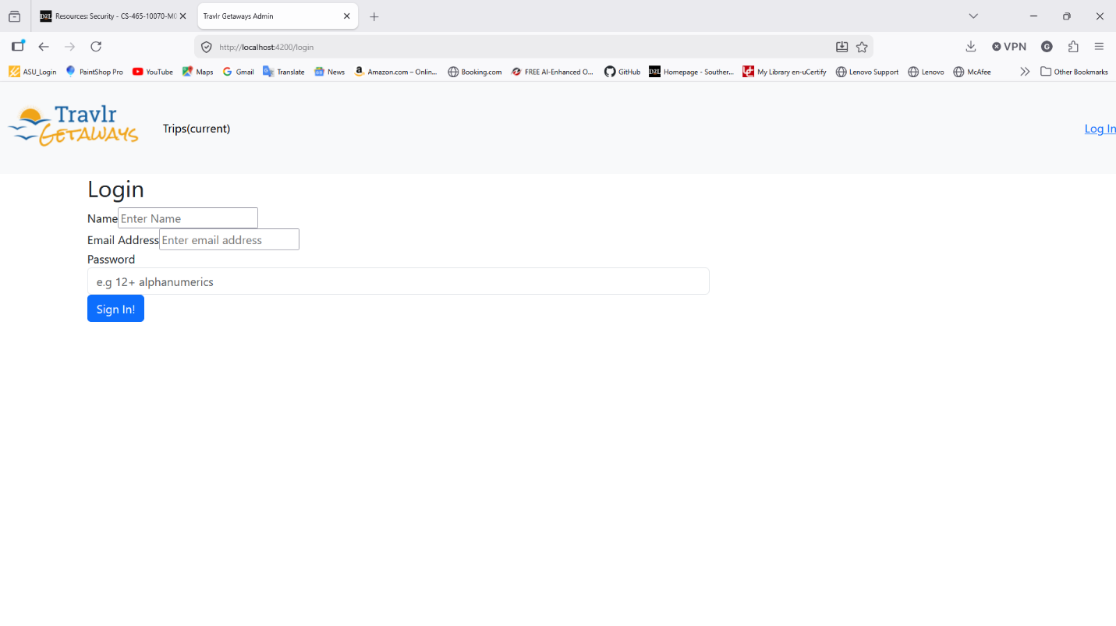
Figure 6 shows the login page.

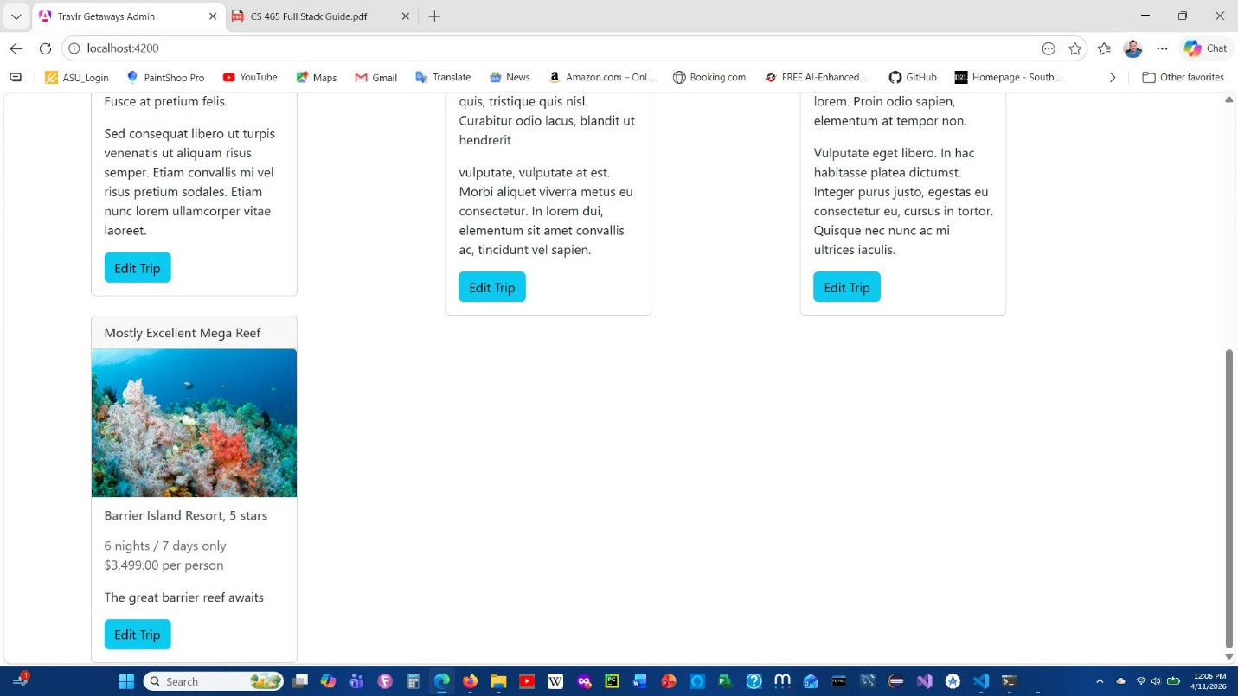
Figure 7 shows the newly added trip and edit buttons on each trip card.

How is the Angular project structure different from that of the Express HTML customer-facing page?

Express used an MVC pattern in structuring the files. There was a model, view and controller. The model was the database, the controller handled the HTTP requests, and the view had the templates that are filled in to render the HTML for the users.

Angular was more of a component structure. Each component has a CSS, HTML, and TypeScript file.

What are some advantages and disadvantages of the SPA functionality? What additional functionality is provided by a SPA compared to a simple web application interaction?

The SPA loads in the beginning, so there is a little delay at first. Once it is loaded, however, the page is fast and responsive. Simple web applications tend to load each page and can frustrate users with long wait times, especially if there is a bad internet connection. Some functions of SPAs can be done offline, since the page is loaded in the beginning.

What is the process of testing to make sure the SPA is working with the API to GET and PUT data in the database? What are some errors you ran into or what are some errors you could expect to run into?

Testing the APIs GET and PUT commands was done with Postman. Once the query is set up, one can enter the values that are in the form. Another way to test is by going to MongoDB directly to see the changes in the database. If the logic isn’t in place, then there won’t be changes in the database and this will indicate an error.

Another error that could potentially happen is a datatype mismatch. If the date is in a different format from the one accepted by the form, there will be an error.

Works Cited

Cyber Writes Team. (2026, January 14). 10 Most Dangerous Injection Attacks in 2026. Retrieved on March 22, 2026 from https://cybersecuritynews.com/injection-attacks/

Devlin, A. (2025). Mastering MEAN Stack: A Step-by-Step Guide to MongoDB, Express.js, Angular, and Node.js for Modern Web Apps. BPB Publications.

Ram, M. (2024, June 18). 6 MEAN Stack Development Common Securities: How to prevent? Retrieved from on March 22, 2026 from https://medium.com/@mukesh.ram/6-mean-stack-development-common-securities-how-to-prevent-ceefd1ae6c1f

Wahab, G. (2025, June 27). MongoDB Performance Tuning: Top 5 Mistakes You Should Avoid. Retrieved on March 22, 2026 from https://www.datapatroltech.com/blog/mongodb-performance-tuning-mistakes

Yadav, V. (2024, June 7). Connect MongoDB with Node.js: A Practical Guide with Mongoose. Retrieved on March 22, 2026 from https://dev.to/vyan/seamlessly-connect-mongodb-with-nodejs-a-practical-guide-with-mongoose-1gk6

